**CORE JAVA ASSIGNMENT 1 – BASIC DATA STRCUTURES**

1.Find out if the given number is an Armstrong number. Logic-if 153 is the supplied value, then 13 + 53 +33 = 1+125+27 = 153 .This is the same as supplied value hence it is an Armstrong number.

**Solution:**

**package** CoreJavaAssignment;

**import** java.util.Scanner;

**import** java.lang.Math;

**public** **class** CheckArmstrongNo {

**public** **static** **void** main(String[] args) {

Scanner input = **new** Scanner(System.***in***);

System.***out***.print("Enter a no. to check Armstrong : ");

**int** number = input.nextInt();

**boolean** result = *isArmstrong*(number);

**if**(result)

{

System.***out***.print("This is an Armstrong Number");

}

**else** {

System.***out***.print("This is not an Armstrong Number");

}

}

**public** **static** **boolean** isArmstrong(**int** inputNumber)

{ **int** sum = 0 , temp = inputNumber ;

**while**(temp!=0)

{

sum+= Math.*pow*((temp%10),3);

temp/=10;

}

**if**(sum==inputNumber)

{

**return** **true**;

}

**return** **false**;

}

}

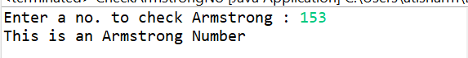



2. Find out all the Armstrong no. between the range 100 – 999.  
  
**Solution:**

**package** CoreJavaAssignment;

**import** java.lang.Math;

**public** **class** ArmstrongBetween100to999 {

**public** **static** **void** main(String[] args) {

**for**(**int** i = 100 ; i <= 999 ; i++)

{

**if**(*isArmstrong*(i))

{

System.***out***.print(i + " ");

}

}

}

**public** **static** **boolean** isArmstrong(**int** inputNumber)

{ **int** sum = 0 , temp = inputNumber ;

**while**(temp!=0)

{

sum+= Math.*pow*((temp%10),3);

temp/=10;

}

**if**(sum==inputNumber)

{

**return** **true**;

}

**return** **false**;

}

}

**Output:**



3. Find the Simple as well as the compound interest of supplied value.

**Solution:**

**package** CoreJavaAssignment;

**import** java.util.Scanner;

**import** java.lang.Math;

**public** **class** SimpleAndCompoundInterest {

**public** **static** **void** main(String[] args) {

Scanner input = **new** Scanner(System.***in***);

**double** principle , interest , timePeriod;

System.***out***.print("Enter the Principle, interest, timeperiod: ");

principle = input.nextDouble();

interest = input.nextDouble();

timePeriod = input.nextDouble();

**double** simpleInterest = (principle * interest * timePeriod);

// SI = P*i*n

**double** compoundInterest = (principle*(Math.*pow*((1+interest),timePeriod)-1));// CI = P((1+i)n + 1)

System.***out***.println("Simple Interest: " + simpleInterest);

System.***out***.println("Compound Interest: " + compoundInterest);

}

}

**OUTPUT:**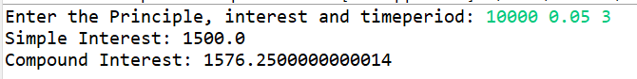

4. Supply marks of three subject and declare the result, result declaration is based on below conditions:

Condition 1: -All subjects marks is greater than 60 is Passed

Condition 2: -Any two subjects marks are greater than 60 is Promoted

Condition 3: -Any one subject mark is greater than 60 or all subjects' marks less than 60 is failed.

**Solution:**

**package** CoreJavaAssignment;

**import** java.util.Scanner;

**public** **class** StudentResultDeclaration {

**public** **static** **void** main(String[] args) {

Scanner input = **new** Scanner(System.***in***);

System.***out***.print("Enter the marks of 3 subjects : ");

**int**[] marks = **new** **int**[3];

marks[0] = input.nextInt();

marks[1] = input.nextInt();

marks[2] = input.nextInt();

**if**(marks[0] > 60 && marks[1] > 60 && marks[2] > 60)

System.***out***.println("Result: Passed Congratulations! ");

**else** **if**( (marks[0] > 60 && marks[1] > 60) ||

(marks[1] > 60 && marks[2] > 60) ||

(marks[0] > 60 && marks[2] > 60) )

System.***out***.println("Result: Promoted");

**else** **if**((marks[0] > 60 || marks[1] > 60 || marks[2] > 60))

System.***out***.println("Result: Failed");

**else**

System.***out***.println("Result: Failed");

}

}

**Output:**

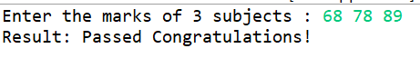  


  
  
  
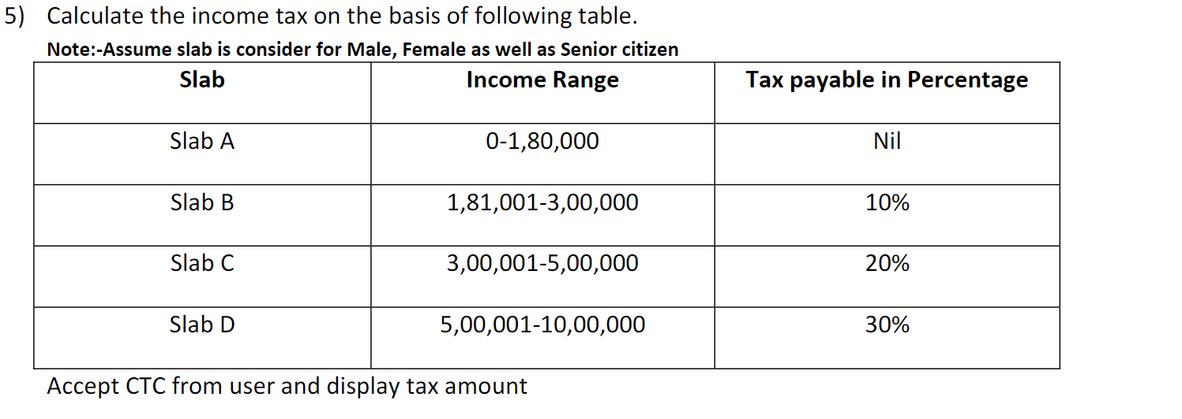

**Solution:  
  
package** CoreJavaAssignment;

**import** java.util.Scanner;

**public** **class** IncomeTaxFromCTC {

**public** **static** **void** main(String[] args) {

Scanner input = **new** Scanner(System.***in***);

System.***out***.print("Enter your current CTC: ");

**double** currentCTC = input.nextDouble();

**double** incomeTax = *incomeTaxFromCTC*(currentCTC);

System.***out***.println("Your Income Tax Value is: " + incomeTax);

}

**public** **static** **double** incomeTaxFromCTC(**double** currentCTC)

{

**if**(currentCTC >= 0 && currentCTC <= 180000)

**return** 0.0;

**else** **if**(currentCTC >= 181001 && currentCTC <= 300000)

**return** (10*currentCTC)/100;

**else** **if**(currentCTC >= 300001 && currentCTC <= 500000)

**return** (20*currentCTC)/100;

**else** **if**(currentCTC >= 500001 && currentCTC <= 1000000)

**return** (30*currentCTC)/100;

**return** -1;

}

}  
**Output:**



**  
**



6. Consider a CUI based application, where you are asking a user to enter his Login name and password, after

entering the valid user-id and password it will print the message “Welcome” along with user name. As per the

validation is concerned, the program should keep a track of login attempts. After three attempts a message

should be flashed saying “Contact Admin" and the program should terminate.

**Solution:**

**package** CoreJavaAssignment;

**import** java.util.Scanner;

**public** **class** Login {

**public** **static** **void** main(String[] args) {

Scanner input = **new** Scanner(System.***in***);

/* Let's assume user has account with UserName: "AmitSingh"

and his password is: Amit@54321 */

**int** loginAttempts = 3;

**do** {

System.***out***.print("Enter Username: ");

String userName = input.next();

System.***out***.print("Enter Password: ");

String passWord = input.next();

**if**(userName.equals("AmitSingh") && passWord.equals("Amit@54321"))

{

System.***out***.println("Welcome " + userName);

**break**;

}

**else**

{ loginAttempts--;

System.***out***.println("Invalid Credentials Login Attempts Left: " + loginAttempts);

}

}**while**(loginAttempts>0);

**if**(loginAttempts == 0)

{

System.***out***.println("Contact Admin!");

}

}

}

**Output:**

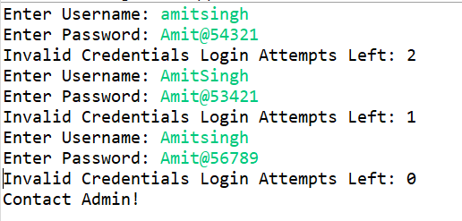

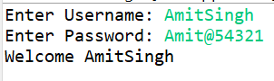

7. There is an Array which is of the size 15, which may or may not be sorted. You should write a program to accept a number and search if it in contained in the array.  
  
**package** CoreJavaAssignment;

**import** java.util.Scanner;

**public** **class** SearchingInArray {

**public** **static** **void** main(String[] args) {

Scanner input = **new** Scanner(System.***in***);

**int**[] intArray = **new** **int**[15];

System.***out***.print("Enter the Elements of Array: ");

**for**(**int** i = 0 ; i < 15 ; i++)

{

intArray[i] = input.nextInt();

}

System.***out***.print("Enter the Element to be searched: ");

**int** elementToBeSearched = input.nextInt();

**int** SearchResult = *linearSearch*(intArray , elementToBeSearched);

**if**(SearchResult == -1)

{

System.***out***.print("Element not found in Array");

}

**else** {

System.***out***.print("Element found in Array at Location " + SearchResult);

}

}

**public** **static** **int** linearSearch(**int**[] intArray , **int** element)

{

**for**(**int** i = 0 ; i < intArray.length ; i++)

{

**if**(intArray[i] == element)

{

**return** i+1;

}

}

**return** -1;

}

}

**Output:**

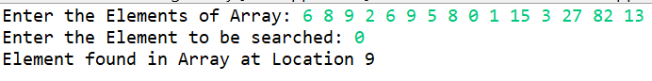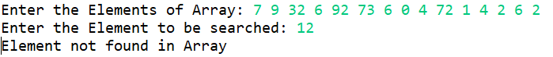

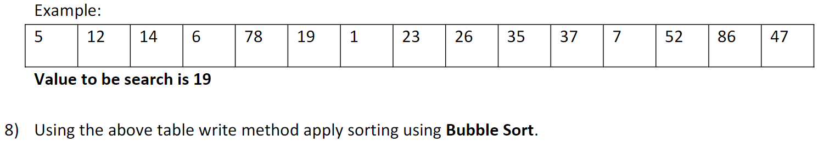

**Solution:**

**package** CoreJavaAssignment;

**public** **class** SortingWithBubbleSort {

**public** **static** **void** main(String[] args) {

**int**[] arr = {5,12,14,6,78,19,1,23,26,35,37,7,52,86,47};

*BubbleSort*(arr);

**for**(**int** i = 0 ; i < 15 ; i++)

{

System.***out***.print(arr[i] + " ");

}

}

**public** **static** **void** BubbleSort(**int**[] arr)

{

**for**(**int** i = 0 ; i < arr.length - 1 ; i++)

{

**for**(**int** j = i+1 ; j < arr.length ; j++)

{

**if**(arr[i] > arr[j])

{

**int** temp = arr[i];

arr[i] = arr[j];

arr[j] = temp;

}

}

}

}

}

**Output:**



9) Accept the marks of three students for the subject say A, B, C. Find the total scored and the average in all the subjects. Also find the Total and Average scored by students in each respective Subject.  
  
**Solution:**

**package** CoreJavaAssignment;

**import** java.util.Scanner;

**public** **class** TotalAndAverageScores {

**public** **static** **void** main(String[] args) {

Scanner input = **new** Scanner(System.***in***);

**int**[][] array2D = **new** **int**[3][3];

**for**(**int** i = 0 ; i < 3 ; i++)

{

**for**(**int** j = 0 ; j< 3 ;j++)

{

System.***out***.print("Enter the Score of Student " + (i+1) + " in Subject " + (j+1) + " : " );

array2D[i][j] = input.nextInt();

}

}

System.***out***.println();

//Sum and Average of scores of Each student in all Subjects:

**for**(**int** i = 0 ; i < 3 ; i++)

{

System.***out***.println(  
"Total score of Student " + (i+1) +  
" is " + (array2D[i][0]+array2D[0][1]+array2D[0][2]) );

System.***out***.println(  
"Average score of Student " + (i+1) +  
" is " + ((**float**)(array2D[i][0]+array2D[0][1]+array2D[0][2])/3.0) );

}

System.***out***.println();

//Sum and Average of score of Each subject:

**for**(**int** i = 0 ; i < 3 ; i++)

{

System.***out***.println(  
"Total score of Subject " + (i+1) +  
" is " + (array2D[0][i]+array2D[1][i]+array2D[2][i]) );

System.***out***.println(  
"Average score of Subject " + (i+1) +  
" is " + ((**float**)(array2D[0][i]+array2D[1][i]+array2D[2][i])/3.0) );

}

}

}

**Output:**

